A Minor Project Mid-term Report on

CAFE RESERVATION SYSTEM

Submitted in Partial Fulfillment of the Requirements for The Degree of Bachelor of Engineering in Information Technology Under Pokhara University

Submitted by:

**Shushil Mishra, 211440**

**Prakash Mahara, 211527**

Date: 2080-10-10



Department of IT Engineering

**NEPAL COLLEGE OF**

**INFORMATION TECHNOLOGY**

Balkumari, Lalitpur, Nepal

**ABSTRACT**

Cafe Reservation System is a computerized cafe reservation system that is designed to provide Cafe to perform operations of reservations. The manual process of waiting tables for customers is extremely tedious. Keeping track of large customer bases and their order details is complicated and time consuming since managing the cafe work and taking their order is required.

This software will be designed using PHP as Server site scripting and MYSQL as its database. The completed project delivers a system that enables the receptionist to record details of the customer, search for unoccupied tables as per requirements and reserve suitable location.

*Keywords****:***  Cafe, JavaScript, Php, Menu, Management

**Table of Contents**

**1. Introductions**

1.1 Problem Statement

1.2 Project Objectives

1.3 Significance of the Study

1.4 Scope and Limitations

**2. Literature Study/Review**

**3. Methodology**

**4. System Design**

4.1 ENTITY RELATIONSHIP DIAGRAM (ERD)

4.2 USE CASE DIAGRAM

**5. BLIOGRAPHY**

**Introductions**

The purpose of this document is to propose a computerized cafe reservation system. Nepal is a growing tourist destination and there has been a good rise in the number of café since the past. Information and Communication Technologies (ICTs) has been rapidly developing and commercializing for the cafe industry. This has prompted cafe and other enterprises in this sector to adopt these technologies.

Cafe Reservation System has all the dynamic versatile features required to smoothly run a Cafe. This project deals with reservation inquiry, single reservation, and group reservation, cancel reservation and recall reservation. During reservation, the details of the customers, type of table required and number of table required are fed in to the system. Once these in formations are entered, the system searches for the unoccupied tables and displays the result. In reservation inquiry, customer can get the information such as price of table and details of tables available.

Café operation will be easy for the receptionist since all data and information will store in the database and it can access anytime.

**1.1 Problem Statement**

This project addresses the issue of delay the customer has to face in a Cafe. Customers have to wait to be handed a menu, next they must wait for their order to be taken, and finally wait for their bill to arrive. This digital menu and ordering system remove the need for the customer to wait for these services. Unpleasant or uncomfortable seating arrangements, inadequate lighting, or disruptive noise levels. Extended wait times for orders, inefficient service, and delays in receiving food and beverages.

**1.2 Project Objectives**

The main objectives of this project are:

* To make an accurate and efficient Coffee and Food ordering system.
* To provide the customer instant access to the Cafe menu and bill.
* To help both the customer and the staff have easier experience without any confusion and miscommunication.
* To provide customers options to choose their seats.

**1.3 Significance of the Study**

The motivation for designing this application came because my family is involved in the cafe business and I personally do not like waiting for long in the cafe or to have to call staff to place an order especially during the peak hours. Moreover, I value recent learning about the JavaScript, HTML, CSS and JSP Programming languages as well as seeing how powerful and dynamic they are when it comes to web designing and applications. The languages used to build this application are JavaScript, HTML and CSS at client facing whereas MySQL database at the back-end because I found them to be extremely useful while working on the technologies.

**1.4 Scope and Limitations**

Scope:

* Enable users to browse available tables.
* Allow customers to reserve specific tables.
* Ensure the system is accessible and user-friendly on mobile browser.

Limitations:

* Reliance on internet connectivity and technology may pose challenges, especially in areas with poor connectivity.
* Some customers, particularly older demographics, may not be comfortable or familiar with using online reservation systems.
* Technical issues or system downtime can disrupt the reservation process and affect customer satisfaction.

**2. Literature Study/Review**

* Review: There are various work performed and being performed in the café reservation system. Cafe still uses manual reservation system for servicing customers. Thus, to overcome this problem, the system lets people check the availability of the table in Cafe of their desire.
* Domain: It is specifically designed to be used for Cafe.
* Existing System: Café has been using the traditional method for recording the data of customers. The receptionist manages these details through paperwork which are stored in cabinets as files. So, these tasks seem very time consuming, less secured and prone to errors.
* Comparison with Existing System-It has numerous advantages over the existing process in the cafe. Our system eliminates the drawbacks of tedious manual process, paper work, low security for personal details of customers and inability to provide table according to the customer’s needs. On top of that, since the records are stored in database, we can update, delete and add information as per requirement.

**3.Methodology**

For this project, we have used the Increment Model of Software Process Model. This model combines linear sequential model with the iterative prototype model. The first increment is a “core product”. The plan addresses the modification of the core product to meet the needs of the customer and the delivery of additional features and functionality

The process is repeated following the delivery of each increment, until the complete product is produced

.

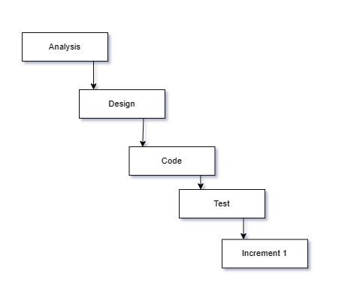

Fig.1: Increment Model

Incremental model includes the following phases:

* Analytic Phase- In this phase, the requirements of the software was analyzed which resulted in “Software Requirement Specifications”.
* Design Phase- In this phase, analysis of the SRS was translated into the system’s design and ER Diagram were developed.
* Coding Phase-This phase involves the coding as per the design and formation of a working system at the end of the process.
* Testing Phase- In this phase, the system was tested. With each testing, certain changes were made as per the suggestion. This was done in an incremental manner until a satisfactory system was made.

**System Design**

**4.1 ENTITY RELATIONSHIP (ER) DIAGRAM**

**Entity – Relationship Diagram**: This depicts relationship between data objects. The attribute of each data objects noted in the entity- relationship diagram can be described using a data object description. Data flow diagram serves two purposes:

1. To provide an indication of how data are transformed as they move through the system.
2. To depict the functions that transformation the data flow.

**Data Objects**: A data object is a representation of almost any composite information that must be understood by the software. By composite information, we mean something that has a number of different properties or attributes. A data object encapsulates data only there is no reference within a data object to operations that act on the data.

**Attributes**: Attributes define the properties of a data object and take on one of three different characteristics. They can be used to:

* Name an instance of data object.
* Describe the instance.
* Make references to another instance in other table.

**Relationships**: Data objects are connected to one another in a variety of different ways. We can define a set of object relationship pairs that define the relevant relationships

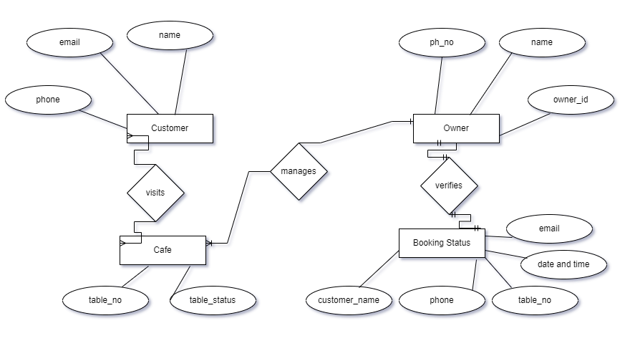

Fig.2: Diagram for Cafe Reservation System

**4.2 USE CASE DIAGRAM**

Use case is a list of steps, typically defining interaction between a role and a system, to achieve a goal.

A use case diagram is a graphic depiction of the interactions among the elements of a system. It is a methodology used in system analysis to identify, clarify, and organize system requirements. In this context, the term "system" refers to something being developed or operated. Use case diagrams are employed in UML (Unified Modeling Language), a standard notation for the modeling of real-world objects and systems.

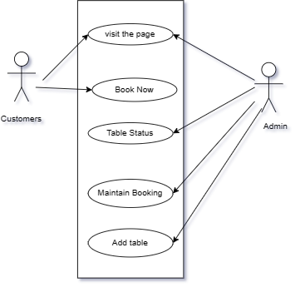

Fig.3: Use Case Diagram for Hotel Reservation System

**BIBLIOGRAPHY**

* S.Pressman “Software Engineering Fundamentals”, Seventh Edition
* [info@ncit.edu.np, NCIT](mailto:info@ncit.edu.np,%20N%20CIT) LMS